
Valid From januari 1 2026
Service Level Agreement
Decos Informatino Solutions, Doclogic, CenterOne, Seneca, ZiuZ Forensics and Digital Investigation, GeoJunxion, Decos Digital and Decos Information Solutios Europe.
Content
1. Changes 3
2. Introduction 4
2.1. References 4
2.2. General characteristics of the SLA and reading guide 5
3. Principles 6
3.1. Which Products and Services does this SLA apply to? 6
3.2. Which services are covered by this SLA? 7
3.3. Eligibility for Support Under This Agreement 11
3.4. Indexing and Payments 14
4. Practical 15
4.1. How do I report a disruption? 15
4.2. How do I determine the priority of my disruption? 15
4.3. What are the resolution times for products? 16
4.4. How does extended 24/7 support work? 19
4.5. Which process should I follow? 19
4.5.1. Questions 20
4.5.2. Wishes or feature requests 20
4.6. How can I view reported issues? 21
4.7. What does the installation process involve for a major release? 21
4.8. What does the test phase of a major release look like for private cloud installations? 22
4.9. Where can information about the releases be found? 22
4.10. Is the sla applicable during the project phase? 22
4.11. Which sla applies to certified partners of the supplier? 22
4.12. What is the process for remote access? 23
4.13. What happens if the sla uptime or resolution times are not met? 23
5. Addenda 24

Changes
The following changes have been made to this SLA:

- Title page: Seneca, GeoJunxion, Decos Digital and Decos Information Solutions Europe have been added to the business units to which this SLA applies.
- Title page: the effective date has been changed from January 1, 2025 to January 1, 2026
- Chapter 2 "Introduction": Seneca, GeoJunxion and Decos Information Solutions Europe and have been added to the business units to which this SLA applies.
- Chapter 3.1: Seneca and GeoJunxion have been added here.
- Chapter 4: Description of different types of support
- General: Geodata delivery added
- Addenda added:
  - Fair use policy





Introduction
This Service Level Agreement (SLA) describes which services you as a client are entitled to in the event of a paid maintenance contract. This SLA applies if you have an agreement with Decos Information Solutions, Decos Information Solutions Europe, Doclogic, CenterOne, Seneca, ZiuZ Forensics, Decos Digital and/or GeoJunxion (hereinafter referred to as "Supplier"). In this context, the following documents are relevant:

- Agreement (in the data processing agreement also called ‘main agreement’, or in regular communication the ‘signed quote’) – This agreement states the conditions under which you obtained the right to use which software applications and/or Data, and how re-transition/the exit plan is established
- Data Processing Agreement – This includes, among other things, how the supplier guarantees the security of personal data and the process in the event of a data breach.
- General Terms and Conditions – Unless otherwise agreed, the General Terms and Conditions of the supplier apply.
  - Optional: If you use the OurMeeting solution, the OurMeeting addendum applies, which includes additions to this SLA.
  - Optional: Dossier Agreements and Procedures (DAP) – This is used to make working agreements regarding responsibilities, procedures, and consultation methods between the client and the contractor.

References
This SLA refers to the following set of documents:

- Applicable to all organizations:
  - General Terms and Conditions - link
  - Whitepaper private cloud - link
  - Wiki - link
  - Trust Center – link
  - Responsible disclosure - link
  - Installation possibilities per software application - link
  - Releasenotes - link
  - Training courses - link
  - Additional SLA services - link
  - Supplier Community - link
  - Signing up for mailings - link
  - Procedure for remote access - link
  - Fair use policy – link
- Specific to Decos Information Solutions:
  - Whitepaper JOIN - link
  - Support portaal (Decos, Doclogic & CenterOne) - link
  - User agreement JOIN Samenwerken - link

- Specific to: Doclogic
  - Support portal (Decos, Doclogic & CenterOne) - link

- Specific to: ZiuZ Forensics and Digital Investigation
  - Support portal (ZIUZ) - link
- Specific to: CenterOne
  - Support portal (Decos, Doclogic & CenterOne) - link
- Specific to: Seneca
  - Support portal (Seneca) - link
- Specific to: GeoJunxion
  - Support portal (Geojunxion) – Link
- Specific to: Decos Digital
  - Support portal (Decos, Doclogic & CenterOne) - link

General characteristics of the SLA and reading guide
SLA Duration and Termination of Agreement
For new modules, the SLA starts on the first day of the software delivery and runs until December 31 of that year. Thereafter, the SLA is automatically renewed annually for one year.
For an increase in the number of user licenses within an existing installation, the SLA term starts after the new license key has been sent and also runs until December 31 of that year. After this, the SLA is automatically renewed annually for one year.
You can send a termination notice by email to info@decos.com. This can be done at the end of the current period, subject to a notice period of at least three months.

Changes
The supplier has the right to revise the SLA and will inform you of the changes one month before the effective date of the change. The client may submit a substantiated objection within one month after the announcement of the changes by sending an email to info@decos.com.

Reading Guide
The first part of this document describes the principles underlying this SLA. We have added this chapter so that it is clear to you - as the customer - what is covered by the SLA and under what conditions.

The second part of this document is practical. You can use this section in daily practice to quickly see how to create a ticket and within what timeframe you can expect a response.

The third part of this document consists of addenda that may apply to you.

In the event of discrepancies between the translated versions of this document, the Dutch version shall prevail.

If you have any questions about this document, you can contact your account manager or send an email to info@decos.com.

Principles

Which Products and Services does this SLA apply to?
This SLA applies to all software applications developed and maintained by Decos Information Solutions, Decos Information Solutions Europe, Doclogic, CenterOne, Seneca, ZiuZ Forensics, Decos Digital and/or GeoJunxion. Additionally, this SLA also applies to (geo)data delivery from GeoJunxion. In this SLA, the term ‘supplier’ is used to refer to the provider of the products and services.

We offer the following environments for products:
Each software application has different installation options. On the installation options page, you can find which installation option applies to the product you use. The type of installation you have influences the requirements placed on you and the capabilities offered by the environment. An important distinction, for example, is that in a shared Cloud environment, fixed update moments apply, whereas with a local installation, update moments can be planned somewhat more flexibly within SLA terms.

On-premises or local installation
The software applications are installed and operational on the client’s local IT infrastructure. The client is responsible for managing the hardware, including the database management system (the ‘DBMS’ such as SQL Server or Oracle), the operating system, file storage, backups, certificates, performing software updates, and security. The client’s responsibilities also apply when the IT infrastructure has been outsourced to a cloud provider other than the supplier.

Private Cloud
The software applications are operational on the supplier’s cloud infrastructure, and the supplier performs technical management. In the private cloud, you as the client are the only one using your environment.

Public Cloud
The software applications are operational on the cloud infrastructure managed by the supplier. All clients with a license for the supplier’s software application in the Public Cloud use the same environment.

We offer the following (geo)data services:
There are different ways you can use our (geo)data services. Depending on the type of (geo)data service, there are different requirements for you as a customer and different possibilities offered by us.

Periodic (geo)Data Export
A periodic (geo)data export is a service where, at a certain frequency, a dataset is made available for you to import into your own environment for your own use. The agreements on data format, scope, size, timeliness, file types, and delivery method are specified in the agreement.

Live Personal (geo)Data (Web) Service
A live personal (geo)data web service is a service where you have access to a specific (geo)data web service via a web service. This is a personal service where you are the only user of the service. The agreements on availability percentage, data format, scope, size, timeliness, file types, and delivery method are specified in the agreement.

Live Shared (geo)Data (Web) Service
A live shared (geo)data web service is a service where you have access to a standardized (geo)data web service via a web service. This is a shared service where multiple customers use the service. The characteristics of availability percentage, data format, scope, size, timeliness, file types, and delivery method are specified in the specifications of the shared service and may be changed by us based on market and cost developments.

For all forms of (geo)data services, the fair-use policy applies.

Which services are covered by this SLA?
Software with Maintenance
The supplier continuously works on improving and maintaining the software applications. We distinguish between preventive and corrective maintenance:
- Preventive maintenance consists of activities that ensure the software continues to function properly, given the originally defined functional and technical scope.
- Corrective maintenance consists of resolving malfunctions, in accordance with the resolution times described in this SLA.
Adjustments resulting from corrective or preventive maintenance are released in new versions of the software applications and can be used by you as the client. Information about this can be found in the release notes.
- Minor release – This release includes bug fixes and small improvements.
- Major release – This release contains all fixes released since the previous major release. In addition, this update often includes new functionalities within the application. For these functionalities, a separate license is usually required to use them.
- Hotfix – This is only provided for an issue with ‘high’ priority.

For cloud installations, the supplier proactively installs major releases on the environments after prior announcement. See also section 4.8.

Minor releases and/or hotfixes are proactively installed for Public Cloud installations. For other installations, minor releases and/or hotfixes are not installed proactively and only upon request during office hours. In case of necessity, for example in the event of a security incident, the supplier may immediately install a minor release and/or hotfix proactively on client environments, where depending on the nature of the incident, the announcement coincides with the update or follows afterward in the case of a zero-day issue.

Innovative developments, such as newly developed functionalities included in a release but not part of your license, can be activated by purchasing a license for them. For this, you can contact your account manager.

Adaptive maintenance is not part of the SLA. Adaptive maintenance involves modifying the software due to external developments. An example of adaptive maintenance is adjusting an interface due to a change in the method or content of data exchange.

For on-premises installations, the software can be downloaded from our wiki, where you will also find the release notes. We recommend having the installation performed by a certified consultant from the supplier; you cannot invoke this SLA if non-certified individuals work on your installation. In case of troubleshooting, you can receive support from a certified consultant from the supplier. New installations (for example, when setting up a new server) must be performed by a certified consultant from the supplier. In these cases, the regular consultancy rate applies. For support options, please refer to the page “Additional SLA Services.”

(Geo)Data Service under Paid Subscription
If you have a paid subscription for a (geo)data service, you are entitled to the periodic or live deliveries as specified in the agreement or the (geo)data service description.

Access to the Support Desk
You can contact the support desk to report malfunctions, ask questions, and create requests. It is important to note that the stated resolution times only apply if the software has been put into production, or in the case of a (geo)data service, the first delivery has been approved. The support desk is available for certified application administrators for products and data specialists for a (geo)data service.

Supplier support portals:
- Support portal Decos - link
- Support portal Doclogic - link
- Support portal CenterOne - link
- Support portal ZIUZ - link
- Support portal Seneca - link
- Support portal GeoJunxion – Link
- Support portaal Decos Digital- link

Disruptions

You have the right to access the support desk to create a ticket for a disruption (corrective maintenance) via the Support portal. Disruptions are prioritized according to the criteria below.

Code | Meaning | Description
1 | High | Disruption or failure of critical components of the software application in the production environment, preventing the process from being executed and for which no workaround is available.
2 | Medium | Disruption within the software application in the production environment that hampers agreed-upon usage but can be remedied with a workaround.
3 | Low | Disruptions that do not significantly hinder business processes.

Known errors
You can use the support portal to view known errors that require a software update.

Questions
You are entitled to the information resources provided by the supplier such as manuals and access to the supplier’s Wiki. You may use these resources to answer substantive questions about using the application. Additional support can be requested for a fee via the support desk.

Change requests and wishes
You have access to the supplier’s Community. Here you can submit development requests and change requests for the software. To make the process run as smoothly as possible, there are a few simple forum rules.

Security Alerts and (Possible) Data Breaches
Report security incidents and (possible) data breaches by creating a ticket through the Support portal. The supplier’s CISO will review the ticket and ensure appropriate follow‑up.

Cloud
These agreements apply to the software applications that run in the Private and Public Cloud.

- Availability
The supplier guarantees a 99.5 % availability for its cloud‑based application. Availability of the software, systems, and related services is measured such that any previously announced or unannounced downtime due to preventive, corrective, adaptive maintenance, or other service activities, and circumstances beyond the supplier’s control, is excluded from the calculation. Examples of events outside the supplier’s influence include a digital attack, total failure of critical infrastructure, or an incident affecting one or more third‑party vendors. Unless the customer provides contrary evidence, the availability measured by the supplier is considered conclusive proof.

Technical maintenance in production environments is scheduled outside business hours. Planned maintenance (e.g., updates) will be announced via email beforehand. For high‑priority disruptions where advance notice isn’t possible, communication will occur during or immediately after the maintenance.

- Software Update
The supplier handles updating the software applications running in the Private and Public Cloud. For details on this process, see paragraph 4.8

- Privacy, Security & Recovery
Information on privacy, security, and recovery can be found on our Trust Center page.

- Externally Initiated Change Requests
This SLA does not cover externally initiated change requests, such as replacing certificates, modifying backup settings, making database changes, or adjusting VPN/FTP connections at the request of the customer, a third party of the customer, or due to changes in guidelines derived from GIBIT, BIO, or other relevant documents. For support options related to these tasks, refer to the “additional SLA services” page.

(Geo)data Services
These agreements apply to live shared (geo)data services.

- Availability
The supplier guarantees the availability of its live shared (geo)data services as described in the service specifications. Availability of software, systems, and related services is measured such that any pre‑announced or unannounced downtime due to preventive, corrective, adaptive maintenance, or other service activities, and circumstances beyond the supplier’s control, are excluded from the calculation. Examples of events outside the supplier’s influence include a digital attack, total failure of critical infrastructure, or an incident affecting one or more third‑party vendors. Unless the customer provides contrary evidence, the availability measured by the supplier is considered conclusive proof.

Technical maintenance in production environments is scheduled outside business hours. Planned maintenance (e.g., updates) will be announced via email beforehand. For high‑priority disruptions where advance notice isn’t possible, communication will occur during or immediately after the maintenance.

- Privacy, Security & Recovery
Information on privacy, security, and recovery can be found on our Trust Center page.

- Externally Initiated Change Requests
This SLA does not cover externally initiated change requests such as replacing certificates, modifying backup settings, making database changes, or adjusting VPN/FTP connections at the request of the customer, a third party of the customer, or due to changes in guidelines stemming from new or amended government legislation. For support options related to these tasks, refer to the “additional SLA services” page.

Eligibility for Support Under This Agreement
To be eligible for supplier support, you must meet the following conditions. If one or more of the listed conditions are missing, the supplier reserves the right to suspend support or charge for services already performed or yet to be performed.

Conditions for on‑Premises Installations
- You maintain a representative acceptance environment. This means that the acceptance and production environments are functionally and technically comparable, including the type and number of interfaces, configured processes, and permission structure.
- You test new software versions before installing them in the production environment.
- You comply with the requirements outlined in the white paper.
- You grant the supplier’s staff remote access to your environment(s).
- You allow the supplier’s staff to install and use analysis tools on your environment(s).
- You are responsible for keeping the software environments up-to-date in the broadest sense. The work required to do so, and any consequences of self-updates, fall outside standard service provision.
- You prevent unauthorized changes by yourself or your employees.
- After a major release from the supplier, you must implement that update in your production environment within 8 weeks. If the major release is not implemented within 8 weeks, the right to support under this SLA lapses.
- Releases required for secure operation of your software must be implemented within the timeframe specified in the communication about that release. You will receive a separate email notification for such cases.
- You may make functional and technical changes in the software environments yourself. If these changes cause defects, any remediation work is outside the SLA.

Conditions for Private Cloud Installations
- You have obtained an acceptance environment from the supplier that is representative of your production environment.
- You ensure that new supplier-software is tested on the cloud acceptance environment within two working weeks.
- You guarantee timely availability to perform these tests and any related follow-up work so that updates can be carried out according to the established release schedule.
- You comply with the requirements outlined in the white paper.
- Our software applications in the Private Cloud may connect to (other) applications running at your organization or on another cloud. To investigate issues in these connections, you must ensure that your external ICT partner, or other third parties such as additional suppliers, are available. Any costs incurred by these parties are borne by the customer.
- If you use Microsoft Office integration combined with a supplier-provided solution, the installation of local client components is outside the supplier’s responsibility and must be rolled out by your own ICT partner at workstations.
- For security reasons, the supplier may deploy a release to production without first offering it to you for testing. An example is an acute security issue. Communication about such situations will occur as soon as possible.
- The administrator account may only be used by the supplier’s staff.
- You may make functional and technical changes in the software environments yourself. If these changes cause defects, any remediation work is outside the SLA.

Conditions for Public-Cloud Installations
- For these software applications the supplier centrally tests the software before it is deployed into production. This means that no acceptance environments are available.
- You may make functional changes yourself in the software environment. If those changes cause errors in the software environment, any corrective work will be outside the SLA.

Conditions for Interfaces on Our Software Applications
- For every unique interface (i.e., connecting to a task-specific application or end-user application) you must hold a valid license.
- An Enterprise Service Bus (ESB) is not considered a task-specific or end-user application. If you use an ESB to facilitate communication between the Supplier’s Software Application and a task-specific or end-user application, you still need a valid license for each application. You also must purchase a license for the exchange with the ESB that sits between them. For example, linking a citizen services application and a permits application to one of our software applications requires two interface licenses; doing so via an ESB would require three licenses.
- A working connection consists of, among other things: two endpoints, PKI/SSL certificates, VPN IPsec tunnel configuration (depending on the hosting model), DNS and TCP routing, and a correctly configured set of settings. The supplier is responsible for the proper operation of the interface software under the correct configuration; you are responsible for the correct configuration. This covers the entire installation – third-party software as well as PKI/SSL certificates, VPN IPsec tunnel configuration (depending on hosting), DNS and TCP routing.
- For diagnosis, the supplier depends on the customer’s ICT department and/or external parties such as other suppliers. You must provide this support. Any costs arising from this are borne by the customer.
- You comply with the conditions mentioned in the whitepaper and the Fair Use Policy.
- After a major release, you must implement it in your production environment within 8 weeks.
- Releases required for secure operation of your software must be implemented within the timeframe specified in the communication about that release. You will receive a separate notification for such cases.
- An interface is intended for data exchange between two applications. It cannot be used for bulk data exchange for (periodic) migration or synchronization. Misuse of an interface voids its warranty and may incur additional charges. Integrations are designed for normal usage conditions. If you load a connection so heavily that excessive traffic occurs, the connection (partially) may cease to function. In such cases, if the issue arises from use deviating from the intended purpose, the customer cannot invoke the SLA timelines and must bring usage in line with the intended use.

Conditions for (Geo)data Services
- You are solely responsible for connecting to the (geo)data service and for purchasing and maintaining any required hardware and licenses.
- If you discover that you cannot use the (geo)data service in your processes, it first must be diagnosed whether the cause lies in your own application landscape, the web connection, or the availability of the (geo)data service. Resolution times start only when it is established that problems are due to our (geo)data service being unavailable. In all other cases no resolution times apply because the issues lie outside our control.
- You are responsible for correctly applying and integrating the (geo)data service into your applications and processes.
- If you or a third party on your behalf makes the (geo)data service unavailable – e.g., by exceeding the web-service usage agreed upon – we may charge you for (recovery) costs, and SLA resolution times do not apply.

Conditions Regarding Functional and Technical Management
- You must ensure that your administrators (functional and technical) possess valid training certificates for the applications you have purchased to guarantee a secure and correctly configured application. This page provides an overview of available trainings.
- Even if the customer outsources functional and technical management tasks to a third party, that third party must hold valid training certificates.

Indexing and Payments
For the services covered by this SLA, a fee is due as agreed in the order. This fee is invoiced annually in advance as a single amount. The supplier may apply an annual index adjustment to this fee. The supplier will communicate any indexing at least one month in advance. For customers with a specific price index agreed upon, that index will be used. In all other sectors the supplier reserves the right to either use a price index or set its own percentage adjustment.

Practical

How do I report a disruption?
As a client, you can create a personal account on our Support portal. After logging in, you may submit a new disruption 24/7 (by creating a ticket) and view the status of ongoing disruptions on this site. The support desk is also available by phone on weekdays between 08:00 and 18:00 CET (UTC +1).

How do I determine the priority of my disruption?
The scheme below shows how you can set the priority of your disruption. The conditions listed in Chapter 3.3 also apply here.
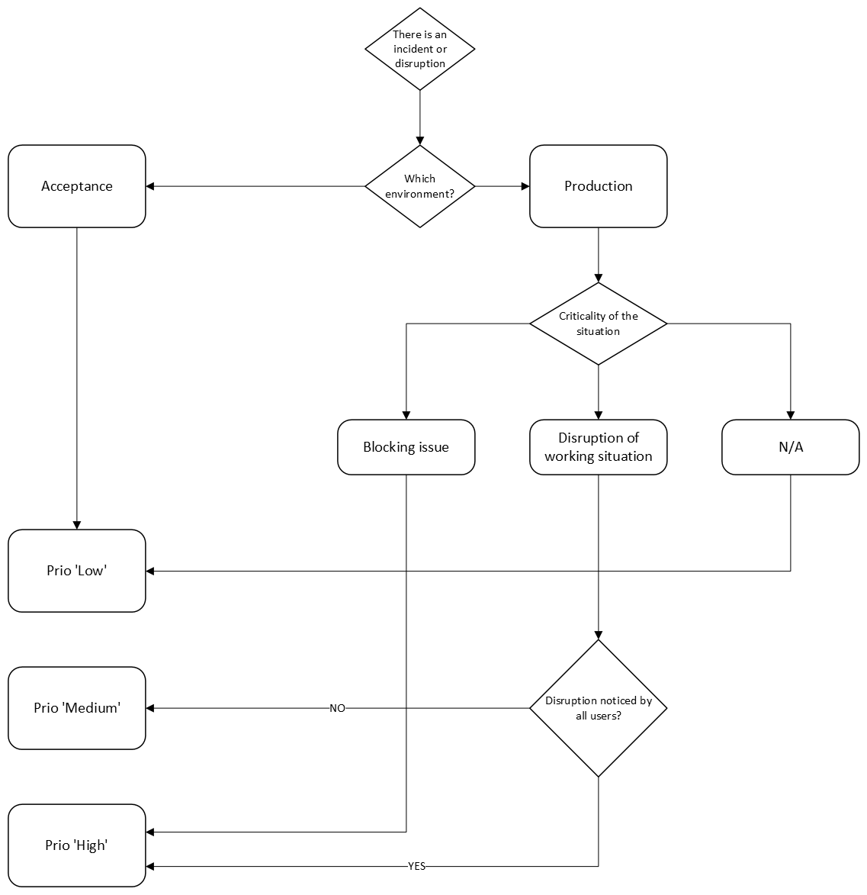

What are the resolution times for products?
Depending on the priority and type of installation, the following resolution times apply. The resolution time starts after the problem analysis is completed. In case of a disruption, the customer must respond promptly and appropriately so that the problem analysis can be carried out as quickly as possible.

Priority >  Off product / service | High (prio 1) | Medium (Prio 2) | Low (Prio 3)
On-premise | Within four working hours a damage-mitigation measure will be implemented.  Within two business days the process-disruptive issue will be resolved by providing a workaround, a software change (“hotfix”), or a configuration adjustment. The priority is then scaled down to medium. | Within eight business days a workaround or configuration adjustment will be proposed.  If the issue disrupts the process, it will be structurally resolved in a new release within three months. The ticket receives the status “In development.”  Once the process disruption is fixed, the priority is reduced to low. | The issue will be permanently resolved in a future release. The ticket receives the status “In ontwikkeling.”
Cloud | Within four working hours a damage-mitigation measure will be implemented.  Within eight working hours the process-disruptive issue will be resolved by providing a workaround, a software change (“hotfix”), or a configuration adjustment. After resolution, the priority is scaled down to medium. | Within three business days a workaround or configuration adjustment will be proposed.  If the issue disrupts the process, it will be permanently resolved in a new release within three months. The ticket receives the status “In development.”  Once the process disruption is fixed, the priority is reduced to low after resolution. | The issue will be permanently resolved in a future release. The ticket receives the status “In ontwikkeling.”
Live (geo)data service | Investigate the cause within four working hours.  Within one business day a workaround or configuration adjustment will be proposed.  Within two business days a software change (“hotfix”) or a configuration modification will be offered.  Once the process disruption is resolved, the priority is scaled down to medium. | Investigate the cause within five business days.  Within ten business days a workaround or configuration adjustment will be proposed.  If the issue disrupts the process, it will be permanently resolved in a new release within three months. The ticket receives the status “In development.”  Once the process disruption is fixed, the priority is scaled down to low. | The issue will be permanently resolved in a future release. The ticket receives the status “In ontwikkeling.”

Priority >  Off product / service | High (prio 1) | Medium (Prio 2) | Low (Prio 3)
Interfaces  * / ** | Investigate the cause within four working hours.  Within one business day a workaround or configuration adjustment will be proposed.  Within two business days a software change (“hotfix”) or a configuration modification will be offered.  Once the process disruption is resolved, the priority is scaled down to medium. | Investigate the cause within five business days.  Within ten business days a workaround or configuration adjustment will be proposed.  If the issue disrupts the process, it will be permanently resolved in a new release within three months. The ticket receives the status “In development.”  Once the process disruption is fixed, the priority is reduced to low. | The issue will be permanently resolved in a future release. The ticket receives the status “In ontwikkeling.”
* For interfaces the stated resolution times apply only if the supplier can diagnose and resolve the problem independently. If external parties are required, we will coordinate subsequent steps with you.
** These resolution times apply to both on‑premises and cloud environments.

Resolution times are measured during the support desk’s operating hours. The measurement is paused if the supplier is waiting for additional information from the customer and/or another supplier.

How does extended 24/7 support work?
On certain products 24/7 extended support applies. Within standard 24/7 support you can create tickets and the support team is available during the hours listed in section 4.1. With 24/7 *extended* support an extended support desk operates after normal business hours, staffed by an international, English‑speaking team that handles high‑priority tickets. For 24/7 extended support the standard SLA times (calculated on the working hours of the regular support desk) still apply; however, tickets are usually resolved faster. Deviations from the SLA are only applicable if explicitly defined in the contract. Ticket creation is identical for both regular 24/7 support and 24/7 extended support.

Which process should I follow?
Below is a schematic representation of the process followed when resolving a disruption. Notifications in the categories “request” and “question” are explained in the following paragraphs.

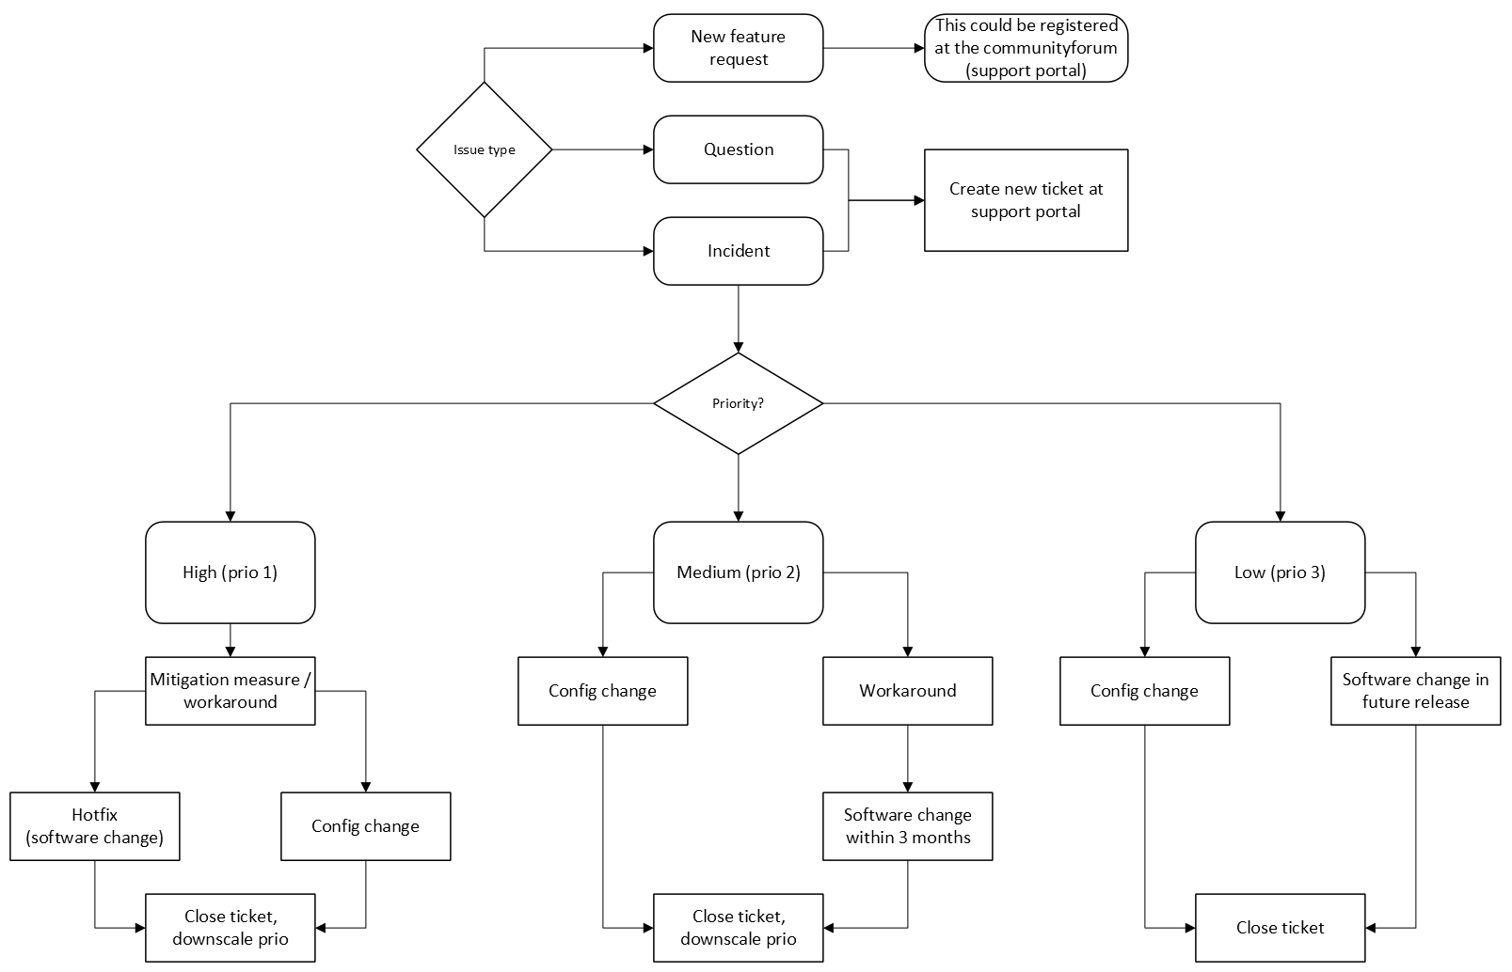

Questions
Through the Support portal you can ask questions about how certain features in the software application work or what the supplier recommends for specific settings. You can submit your question by creating a ticket. A question is never blocking the execution of processes and always receives a low priority. The supplier will help you through one of the following methods:

1. Refer to the user manual
2. Refer to the Wiki page
3. Advise on taking training
4. Advise on hiring a consultant (see cost estimate)
5. Advise discussing the question with your account manager

Which process can you follow if you have any questions:
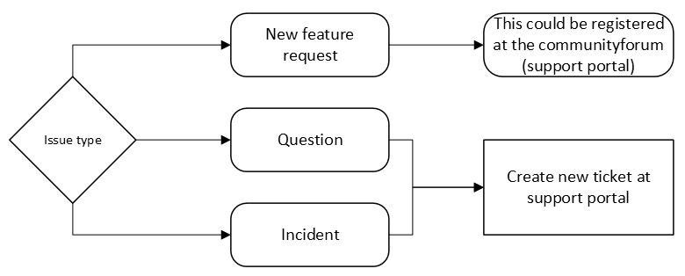

Wishes or feature requests
You have the right to access the supplier’s Community. There you can submit development requests and change requests for the software. To ensure the process runs as smoothly as possible, we have established a few simple forum rules.

Which process can you follow if you want to request a new feature:

How can I view reported issues?
On the Support portal you have an up‑to‑date view of your open and closed tickets. Additionally, you can receive a quarterly overview of all support notifications. For this we refer you to the cost estimate for individual services; you may contact the support team to learn about the available options.

What does the installation process involve for a major release?
Depending on your installation type, the deployment process for a new major release looks as follows:
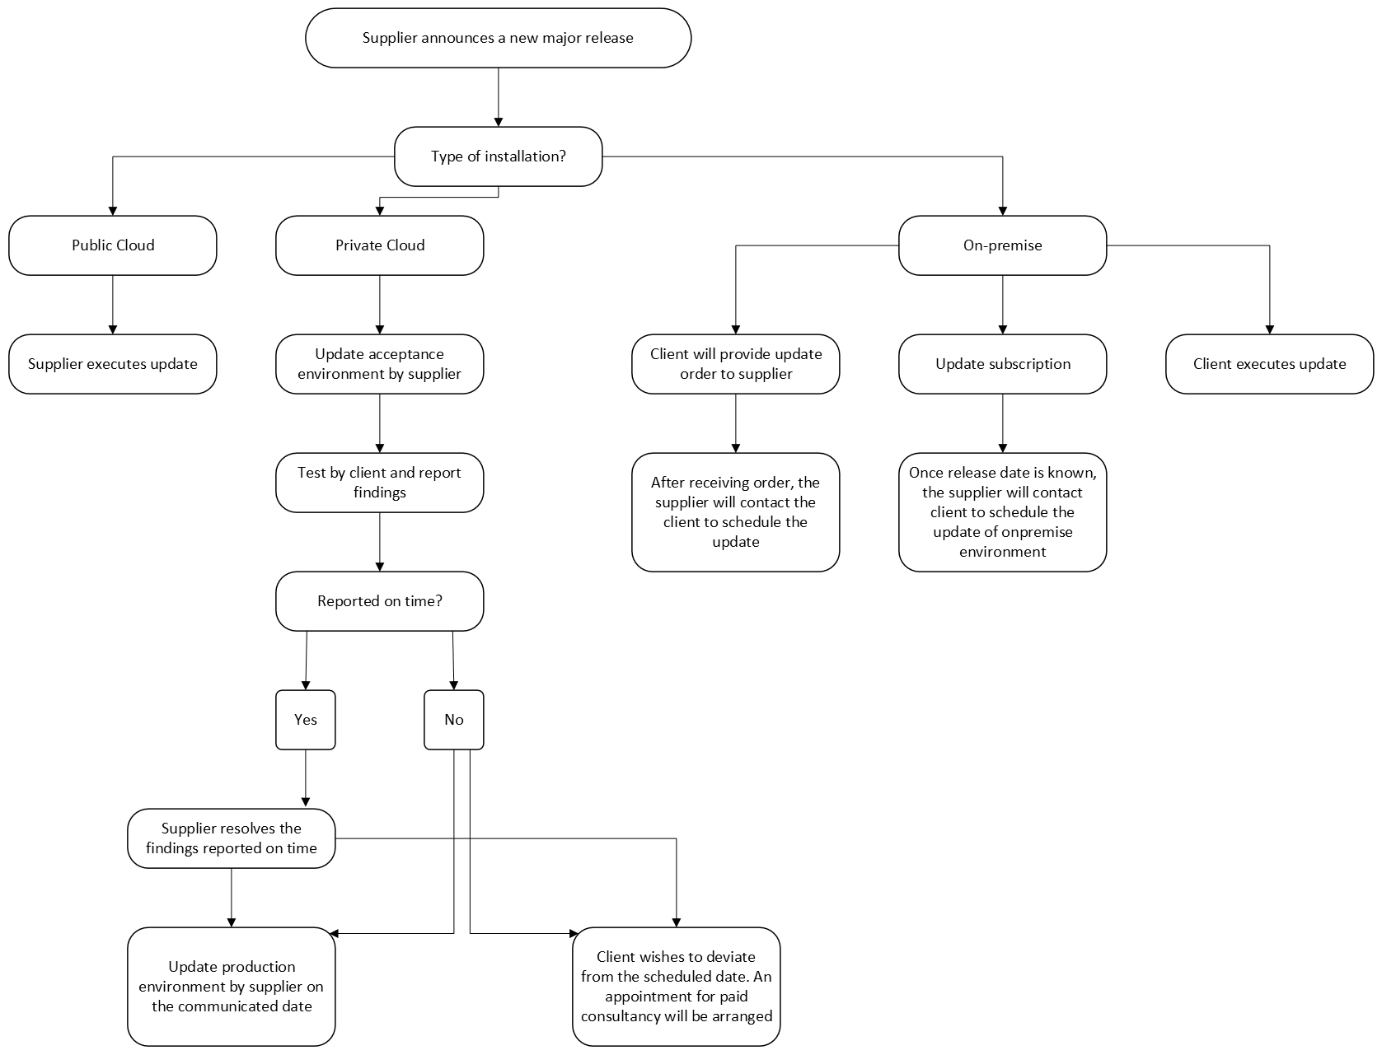

You will always be notified by the supplier in advance about the update via a general email.

What does the test phase of a major release look like for private cloud installations?
The supplier will inform you in advance of the update schedule for a major release via an email.

The supplier uses a fixed period of four weeks between installing on the acceptance environment and deploying to production. This gives you ample time to test your own processes and interfaces. Report blocking issues to the support desk, which will resolve them before the production environment is updated.

During these four weeks the following activities are carried out:
Week 1 | Update the acceptance environment and start the test phase
Week 2 | Test phase and log issues
Week 3 | Resolve blocking issues and perform any necessary retesting
Week 4 | After that, update the production environment.

Where can information about the releases be found?
An up‑to‑date overview of released and scheduled releases can be found on the release notes page. Important changes and major releases are announced by the supplier via email, which you may subscribe to. It is your responsibility to ensure that we have your correct contact details and that you are subscribed to the appropriate emails.

Is the sla applicable during the project phase?
During the project phase you have access to the information resources and the support desk. The resolution times specified in this SLA apply after written acceptance of the project. Your primary point of contact during implementation is your project manager; during the maintenance phase it is the support desk.

Which sla applies to certified partners of the supplier?
This SLA also applies to agreements that the supplier has entered into with certified partners. Depending on the arrangement, the supplier’s certified partner may be responsible for first‑ and/or second‑line support tickets. The resolution times specified in this SLA take effect as soon as a partner reports an issue to us via the support channel. Depending on the SLA you have signed with the supplier’s certified partner, the overall turnaround time may be longer than the times stated in this SLA.

What is the process for remote access?
It is important that you are sure you are dealing with a supplier employee during a remote session. You also have responsibilities in this regard. We safeguard this through a process, which you can review via the Support portal.

What happens if the sla uptime or resolution times are not met?
If the SLA uptime of a product or service, or the resolution times, are not met due to an issue that is clearly attributable to us and does not fall under the stated exceptions, we may compensate you for this. Compensation is calculated by providing you with one hour of consultation per 24 hours that the deadlines were exceeded or the software was unavailable, without charging you for it. This compensation is always paid in kind (in nature) and is not deducted from the invoice, nor does it lead to a refund of partially paid invoices.

Addenda
- Fair Use Policy – [Link]
- Remote Access Procedure – [Link]
- Optional: If you use the OurMeeting solution, the OurMeeting addendum applies, adding provisions to this SLA – [Link]
- Optional: If you use the JOIN Samenwerken solution, the following user agreement applies – [Link]

Certificates have a maximum validity period of two years. After that, you must have your administrators re‑certified.
For installations in the private cloud and on‑premises, this means that support will still be provided for eight weeks on minor and major releases older than the latest major release after the time of the most recent major release. An overview of our releases can be found on our Wiki.
The supplier offers a range of paid and free integration options with software from both the supplier itself and third‑party vendors. Developing and maintaining this software incurs costs, which we have incorporated into a purchase price with annual maintenance or an annual subscription fee. To keep our service affordable it is important that these integrations are used as intended and priced accordingly. The supplier reserves the right to conduct an audit at its own expense to verify that the customer meets the stated requirements.
Private cloud and on‑premises installations: This means that there will still be eight weeks of support for minor and major releases older than the latest major release after the time of the most recent major release. An overview of our releases can be found on our Wiki.
Certificates have a maximum validity period of two years. After that, you must have your administrators re‑certified.
For Dutch municipalities that use the GIBIT terms, we, for example, apply the CBS service-price index category 62: Computer programming, consulting and related services.
See paragraph 4.2 How do I determine the priority of my disruption?
This concerns the availability of the live web service itself, not the currency or quality of the data. For issues with data currency and quality there may be underlying causes—such as data mining—that occur manually and cannot always be resolved within a short time frame.
Only if contractually agreed upon.
Note that this diagram does not apply to (geo)data services; see the description in section 3.1 for those.
When you do not have an acceptance environment, it is impossible to test a release beforehand. Any problems that arise from putting into production a version that has not been tested by you are the customer’s responsibility and will **not** be considered a shortcoming in the delivery of the service. Any restoration costs will be charged accordingly.

